E-β-farnesene synergizes the influence of an insecticide to improve control of cabbage aphids in China

Liang-Liang Cuiª, Jie Dongª, Frédéric Francis^{b}, Ying-Jie Liuª, Stéphanie Heuskin^{c}, Georges Lognay^{c}, Ju-Lian Chen^{d}, Claude Bragard^{e}, John F Tooker^{f}, Yong Liuª
ª College of Plant Protection, Shandong Agricultural University, Taian, Shandong 271018, PR China
^{b} Functional and Evolutionary Entomology, Gembloux Agro-Bio Tech, University of Liege, Passage des Déportés 2, 5030 Gembloux, Belgium
^{c} Laboratory of Analytical Chemistry, Gembloux Agro-Bio Tech, University of Liège, Passage des Déportés 2, 5030 Gembloux, Belgium
^{d} State Key Laboratory for Biology of Plant Diseases and Insect Pests, Institute of Plant Protection, Chinese Academy of Agricultural Sciences, 2 West Yuanmingyuan Road, Beijing 100193, PR China
^{e} Earth and Life Institute, Applied Microbiology-Phytopathology, Catholic University of Louvain, 1348 Louvain-la-Neuve, Belgium department of Entomology, The Pennsylvania State University, 501 ASI Bldg, University Park, PA 16802, USA

ABSTRACT
Extensive use of pesticides to control insect pests can have negative effects on the environment, natural enemies and food safety. The aphid alarm pheromone, E-β-farnesene (Eβf), appears to hold strong potential for controlling a wide variety of aphid pests. To understand the control potential of Eβf, we used field experiments in a factorial design to test its influence and that of the insecticide imidacloprid on populations of aphids Lipaphis erysimi (Kaltenbach) and Myzus perskae (Sulzer) on Chinese cabbage Brasska rapa pekinensis (Brassicales: Brassicaceae). Our results showed imidacloprid treatment alone can significantly decrease aphid populations, and that combining insecticide with Eβf further reduced numbers of apterous aphids at distances of 5 m from pheromone emitters in two years of our experiments. Our results demonstrate that imidacloprid can be effective in reducing the abundance of aphids in Chinese cabbage fields, but the degree of control can be even stronger in the presence of Eβf.
Keywords : Lipaphis erysimi ; Myzus persicae ; Imidacloprid ; E-β-farnesene ; Chinese cabbage

1. Introduction
Conventional pesticides can be an effective tool to control pest populations, but over-reliance on synthetic compounds carries environmental and human-health risks that render their repeated use unsustainable (Hart et al., 2003; Pimentel, 2005). Therefore, it is prudent to explore alternatives to conventional pesticides to improve the sustainability of pest management. By altering herbivore behavior or manipulating natural enemy populations, insect-derived semiochemicals have been recognized as potential alternative tools for the control of insect pest populations (Rodriguez and Niemeyer, 2005). Among semiochemicals relevant for improved aphid control, aphid alarm pheromone is among the most promising (Schwartzberg et al., 2008).
Alarm pheromone is emitted from the cornicles of aphids when they are attacked by natural enemies and signals the risk of attack to others (Edwards et al., 1973). When other aphids detect this cue, they remove their stylets from the host plant and fall, jump, or walk away to escape potential danger (Edwards et al., 1973; Montgomery and Nault, 1977; Roitberg and Myers, 1978; Wohlers, 1981; Braendle and Weisser, 2001). Aphids that sense alarm pheromone do not appear to release additional pheromone (Hatano et al., 2008; Verheggen et al., 2008b). Alarm pheromones are emitted by nearly all aphid species, and the sesquiterpene E-β-farnesene (Eβf), the most common component, has been found in more than 40 aphid species (Xiangyu et al., 2002). Eβf is the only volatile compound identified in the alarm pheromone of 13 aphid species (Francis et al., 2005). For other aphid species, the production of Eβf is often accompanied by other minor components (Nishino et al., 1977; Pickett and Griffiths, 1980). Although Eβf is used by many aphid species, some species are more responsive to alarm pheromone than others (Losey and Denno, 1998), with variation in response even among different clonal lines of the same species (Muller, 1983; Braendle and Weisser, 2001 ). Aphid alarm pheromone release influences the responses of aphids in the presence of predators and parasitoids, but also has longer-term consequences for aphid colony composition and dispersal (Su et al., 2006, Schwartzberg et al., 2008).
Studies of the ecological importance of Eβf under natural conditions are necessary to demonstrate its applicability to pest control; however such studies can be challenging because synthetic Eβf is unstable when exposed to air (Dawson et al., 1990). To overcome this challenge to developing Eβf as a pest control tool, it is prudent to explore natural sources of Eβf. Various plant families also emit Eβf, including Poaceae (Turlings et al., 1998), Solanaceae (Agelopoulos et al., 1999), Malvaceae (Röse and Tumlinson, 2004), Lamiaceae (Bruce et al., 2005) and Asteraceae (Heuskin et al., 2009), and in some plant species, such as wild potato, Solatium berthaultii Hawkes, Eβf may act as a natural aphid deterrent (Gibson and Pickett, 1983). A transgenic line of Arabidopsis thaliana (L) Heynh (Brassicales: Cruciferae) has even been produced that carries the genes for synthesizing Eβf (Beale et al., 2006). Plant essential oils with high Eβf content are a promising source of material, particularly because formulations of essential oils are likely to prevent aerial oxidation of Eβf (Bruce et al., 2005). Although some essential oils with Eβf content have been identified from a few plant species (Dawson et al., 1990; Bruce et al., 2005; Heuskin et al., 2009, 2010), few experiments have been conducted with these oils to test their influence on aphid populations under field conditions. One report demonstrated that the number of pea aphids, Acyrthosiphon pisum (Harr.), on spring sown field beans, Vicia fabae L., could be reduced by use of the essential oil of Hemizygia petiolata Ashby with Eβf content (Bruce et al., 2005).
In this paper, Eβf, with a high purity degree, which was isolated from Matricaria chamomilla L. (Asterales: Asteraceae) essential oil by means of a fast and simple process (Heuskin et al., 2009, 2010), was applied to control two aphid species, Lipaphis erysimi (Kaltenbach) and Myzus persicae (Sulzer) (Hemiptera: Aphididae), which are major pests of cruciferous crops, such as Chinese cabbage Brassica rapa pekinensis (Brassicales: Brassicaceae), the primary vegetable crop in northern China. M. persicae and L. erysimi are usually found concurrently on Chinese cabbages in fields of Shandong province. Populations of these aphid species damage crops by removing photoassimilates from phloem and vectoring numerous plant viruses (Harris and Maramorosch, 1977; Foster et al., 2000; Verheggen et al., 2009; Summers et al., 2010). Therefore, the primary goal of this study was to test the potential of M. chamomilla-derived Eβf to improve control of two aphid species, L. erysimi and M. persicae in Chinese cabbage fields.

2. Materials and methods
2.1. Field experimental design
Field experiments were conducted on experimental farmland at Shandong Agricultural University, Shandong Province of China in 2009 and 2010. Four treatments were (a) control; (b) Eβf [83.8% ± 0.3, extracted by flash chromatography from essential oil of M. chamomilla L. (Heuskin et al., 2010) provided by Dr. S. Heuskin and Prof. F. Francis] only; (c) a low dose of imidacloprid (10 g ai ha⁻¹ 2.5%, EC, Guangxi Tianyuan Biochemistry Co., Ltd; recommended dose: 20-22.5 g ai ha⁻¹) treated plots; and (d) low dose of imidacloprid with Eβf. A completely randomized design was used with three replications. The plots measured 10 m x 25 m, and were separated along all edges by paths (10 m). Chinese cabbage ('Beijing new 3', Beijing Jingyanyinong SciTech Development Center) was planted in rows with 60-cm spacing. The plants were sown on August 15th, 2009 and August 17th, 2010. All plots were fertilized with 110-50-150 (N-P-K) kg ha⁻¹ and no herbicides were used during the growing season. A total of five applications of imidacloprid were made per season. The first application occurred seven days before the first sampling date in treatment plots (c) and (d), and the other four applications occurred after every sampling date. Eβf was released using 1-cm diameter rubber septa, allowing the chemical to be slowly released. One hundred microlitres of Eβf solution in paraffin oil was added to the rubber septa and this amount was added again every seven days. In laboratory conditions at 20°C, relative humidity of 65% and air flow 0.5 L min⁻¹, 76 µg of Eβf was released from the formulation per seven days (Dr. S. Heuskin, unpublished data).
To sample alate aphid populations, yellow pan traps (26 cm diameter, 10 cm depth) were placed on platforms 10 cm above the ground in all plots. The traps were filled with a dilute detergent solution (Diao Brand, Nice Group Co., Ltd.). In plots (b) and (d), an Eβf releaser was mounted centrally close to the liquid surface of the trap. A transparent plastic cover was placed above the septa to protect them from rain. The treatments began when the Chinese cabbage reached the rosette stage (15 September 2009 and 22 September 2010). The plots were irrigated when plants were at the rosette and heading stages.
2.2. Cabbage aphid sampling
To quantify the influence of treatments on aphid populations, we determined the number of cabbage aphids present on cabbage leaves in the different plots every seven days for five sampling dates. Within each plot, we chose four sampling sites that were located 5, 10, 15 and 20 m from the yellow traps. From each sampling site, we counted the number of aphids (alatae and apterae) on leaves of 10 plants.
On each sampling date, the contents of yellow traps were collected. All aphids in the traps and on 12 Chinese cabbage leaves from a randomly chosen cabbage plant in each plot were brought back to laboratory and identified under a dissecting microscope. The numbers and species of insects, including natural enemies, were recorded.
2.3. Data processing and statistical analysis
Two-way analysis of variance (ANOVA, general linear model procedure) was used for aphid counts (summed across sampling dates) with treatment and distance as fixed effects. Mean separation tests (Duncan test) were used for all fixed effects. All data were transformed to meet assumptions of normality using log₁₀(x + 1) (SPSS, version 16.0 for Windows). The relationship between the deterrent rate (Y) and distance from the Eβf releaser (x) was determined using cubic regression models: Y = b₀ + b₁x + b₂x² + b₃x³, with:
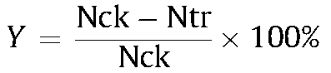
Nek is the number of aphids on 10 plants from control and imidacloprid plots, and Ntr is from Eβf and 'Eβf + imidacloprid' plots. Data from control and Eβf plots, and imidacloprid and 'Eβf + imidacloprid' plots were combined as two groups to analyze the deterrent rate. Cubic models were generated using SPSS. With the exception of aphid densities on plants and in traps, the aphid data represented the mean of five samples.
3. Results
3.1. Population dynamics of the two main aphid species
The dynamics of aphid populations over the two years of our experiments appeared similar between the two dominant aphid species (Fig. 1; M. persicae and L. erysimi), so the data were combined for analysis. L. erysimi was predominant from the middle of September to the end of October, but the proportion of M. persicae increased as the temperatures decreased (Fig. 1). A few non target aphid species were also found in the yellow traps (e.g. Aphis gossypii Glover); however, Chinese cabbage is not a host plant for these aphid species.
3.2. The effects of treatment and distance
Analysis of variance detected significant differences in alatae and apterae populations across treatment in both 2009 and 2010 (Table 1). Distance significantly influenced the number of apterae in both years and the number of alatae in 2009 only. Moreover, analysis revealed significant interactions between treatment and distance for apterae in both years.
There was no significant effect of 'Eβf treatment on alatae and apterae, but 'imidacloprid' and 'Eβf + imidacloprid' treatments significantly decreased the alatae and apterae populations in both 2009 and 2010. In 2009, apterae abundance at 5 m was significantly lower than that at 15 m and 20 m, and no significant difference was found between 5 m and 10 m. In 2010, apterae abundance at 5 m was significantly lower compared with 10 m, 15 m and 20 m. For alatae, in 2010, there was no significant difference among distances. In 2009, alatae abundance at 5 m was significantly lower than that at 10 m and 20 m (Table 2).
Interaction effects between treatment and distance are shown in Table 3. Eβf alone was more effective at 5 m than at any other distance in 2009 and 2010. For 'Eβf + imidacloprid' treatment, significant differences were not found between 5 m and 10 m and between 5 m and 15 m in 2009. Moreover, apterae abundance was significantly lower at 5 m than that at 20 m in 2009. In 2010, 'Eβf + imidacloprid' was more effective at 5 m compared with 10 m, 15 m and 20 m.
3.3. Association between the deterrent rate and distance from Eβf releaser in plots with and without imidacloprid treatment
According to the association between deterrent rate of Eβf and distance, the cubic models for the deterrent rate in the fields not sprayed with imidacloprid were established with the following equation: Y = 327.220 - 0.153x³ + 6.344x² - 82.254x (F = 3.687, P = 0.062, R² = 0.580). For imidacloprid-sprayed fields (Fig. 2) the following equation was used: Y = 304.640 - 0.195x³ + 6.866x² - 74.766X (F = 13.149, P = 0.002, R² = 0.831).

Table 1 : ANOVA statistics for the effects of treatment and distance on cabbage aphid abundance.
Source of variation | df | 2009 |  |  |  | 2010
Source of variation | df | Alatae |  | Apterae |  | Alatae |  | Apterae
Source of variation | df | F-value | P | F-value | P | F-value | P | F-value | P
Treatment | 3,32 | 114.19 | <0.0001 | 305.78 | <0.0001 | 28.15 | <0.0001 | 570.02 | <0.0001
Distance | 3,32 | 5.47 | 0.004 | 4.18 | 0.013 | 0.02 | 0.995 | 99.89 | <0.0001
Treatment*Distance | 9,32 | 1.66 | 0.141 | 7.20 | <0.0001 | 1.02 | 0.447 | 18.14 | <0.0001

Table 2 : Effects of treatment and distance on cabbage aphid abundance.
 | 2009 |  | 2010
 | Alatae | Apterae | Alatae | Apterae
Treatments
(a)CK | 5.86 ± 0.49_{a} | 37.31 ± 3.03_{a} | 28.67 ± 2.54_{a} | 142.90 ± 8.65_{a}
(b) Eβf | 5.20 ± 0.48_{a} | 32.82 ± 4.33_{a} | 26.90 ± 1.30_{a} | 131.71 ± 11.07_{a}
(c) Imid | 1.51 ± 0.20_{b} | 4.51 ± 0.50_{b} | 20.07 ± 1.35_{b} | 21.25 ± 3.63_{b}
(d) Eβf | 0.76 ± 0.12_{c} | 2.02 ± 0.34_{c} | 12.68 ± 0.82_{c} | 16.81 ± 3.83_{c}
+ Imid
Distances
5 m | 2.78 ± 0.51_{c} | 13.33 ± 3.64_{b} | 21.61 ± 2.12_{a} | 50.52 ± 14.31_{b}
10 m | 3.52 ± 0.73_{ab} | 18.70 ± 4.76_{ab} | 22.53 ± 2.39_{a} | 91.88 ± 18.65_{a}
15 m | 2.82 ± 0.76_{bc} | 21.55 ± 6.03_{a} | 21.40 ± 1.73_{a} | 87.85 ± 23.84_{a}
20 m | 4.22 ± 0.91_{a} | 23.07 ± 6.65_{a} | 22.77 ± 3.44_{a} | 82.42 ± 16.90_{a}
Mean ± SE abundance of cabbage aphids (Numbers per 10 Chinese cabbage) in Chinese cabbage experimental fields. Values of cabbage aphid alatae and apterae among different treatment and distance in each year followed by the same letter are not significantly different at the 5% level (Duncan test). Imid represents imidacloprid.

Fig. 1. Densities of two main cabbage aphid species in cabbage fields during the whole period of sampling in both 2009 and 2010. Error bars indicate standard errors of means (SE).
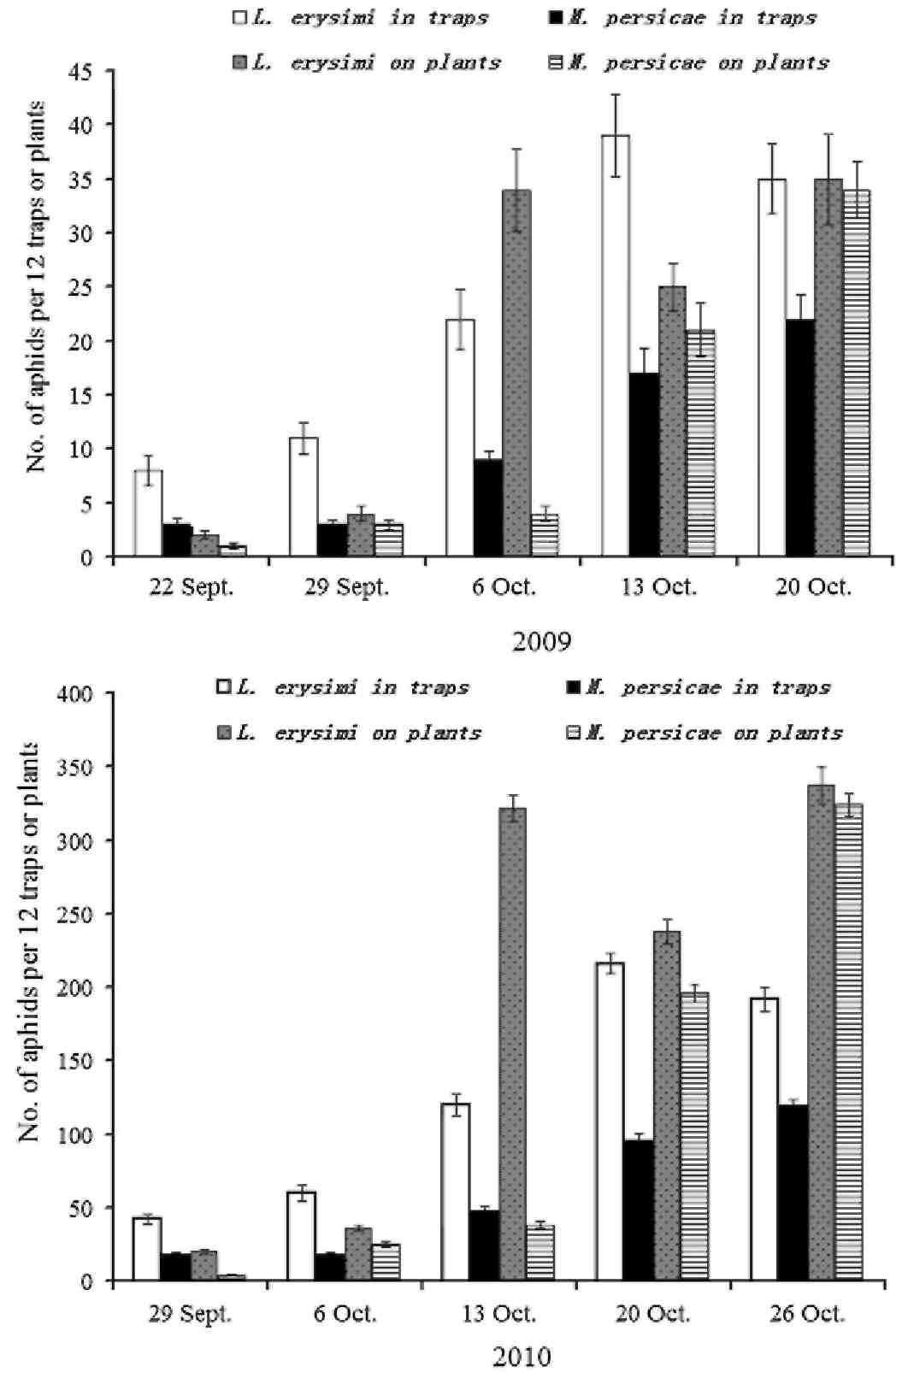

Table 3 : Interaction of treatment and distance for cabbage aphid apterae.
Year | Treatments | Distances
 |  | 5 m | 10 m | 15 m | 20 m
2009 | (a)CK | 32.50 ± 3.23_{a} | 30.83 ± 2.60_{a} | 41.53 ± 5.49_{a} | 44.37 ± 9.40_{a}
 | (b) Eβf | 14.47 ± 0.53_{b} | 37.17 ± 3.44_{a} | 40.00 ± 5.14_{a} | 41.27 ± 10.06_{a}
 | (c) Imid | 6.67 ± 0.68_{c} | 4.33 ± 0.33_{cd} | 3.87 ± 1.17_{d} | 3.18 ± 0.44_{d}
 | (d) Eβf+Imid | 1.33 ± 0.33_{ef} | 2.47 ± 0.35_{de} | 0.80 ± 0.42_{f} | 3.46 ± 0.28_{d}
2010 | (a)CK | 109.67 ± 0.60_{bc} | 142.93 ± 17.65_{ab} | 176.07 ± 12.71_{a} | 142.93 ± 8.40_{ab}
 | (b) Eβf | 84.23 ± 5.33_{c} | 160.20 ± 11.02_{a} | 151.73 ± 24.89_{ab} | 130.67 ± 13.84_{ab}
 | (c) Imid | 5.60 ± 0.92_{h} | 29.87 ± 3.13_{d} | 14.60 ± 1.10_{f} | 34.93 ± 1.41_{d}
 | (d) Eβf + Imid | 2.57 ± 0.34_{i} | 34.53 ± 1.46_{d} | 9.00 ± 1.44_{g} | 21.13 ± 4.53_{e}
Mean ± SE abundance of cabbage aphid apterae (Numbers per 10 Chinese cabbage) in Chinese cabbage experimental fields. Values of apterae in each year followed by the same letter are not significantly different at the 5% level according to mean separation tests of interaction effects (Duncan test). Imid represents imidacloprid.

Fig. 2. Relationships between the deterrent rate (Y) and distance (x) from the E-β-farnesene emitter in imidacloprid-treated and not treated plots.
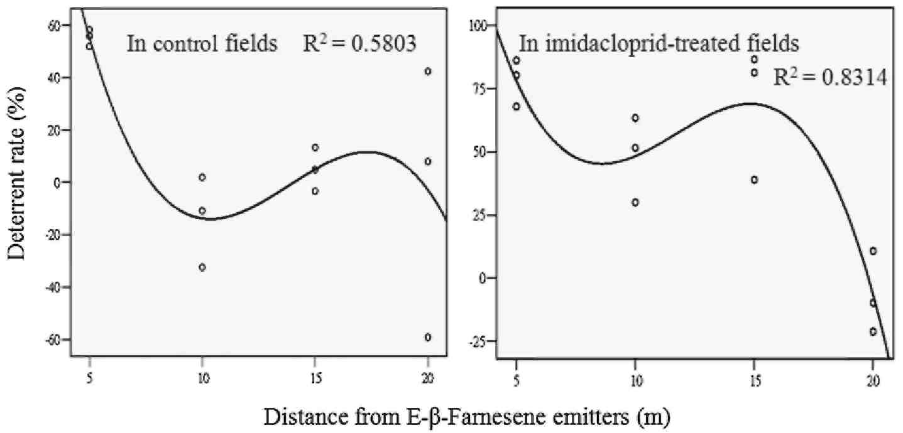

4. Discussion
The influence of synergistic of Eβf and insecticide on cabbage aphids was consistent across the two years of our study, despite differences in the number of aphids between the two years. In 2010, aphid populations were greater than in 2009, likely due to differences in weather conditions; the autumn of 2009 was rainy and cold, whereas it was dry and warm in 2010. Our results indicated that Eβf alone had very little effect on alatae and apterae (Table 2), but this treatment significantly decreased the apterae populations up to a distance of 5 m from the emitter (Table 3). When combined with imidacloprid treatment, apterae populations were further reduced at 5 m from the emitters (Table 3). This decrease resulted in aphid populations that were lower than imidacloprid treatment alone at some distances.
In addition to functioning as a deterrent to alatae, Eβf can also lead to a "pseudo crowding" effect, inducing a higher proportion of winged morphs among offspring (Kunert et al., 2005). The mean deterrent rate distance was highest at 5 m (in fields that did not receive imidacloprid: 55.4%; in imidacloprid-treated fields: 78.0%) (Fig. 2). Aphids that disperse following exposure to alarm phero-mone spend significantly more time wandering than unexposed aphids (Phelan and Miller, 1982), but most exposed individuals recolonize plants within an hour of exposure (Calabrese and Sorensen, 1978). This increased movement causes aphids to use more energy, but also can increase exposure to insecticides (Griffiths and Pickett, 1980). Moreover, because imidacloprid can have systemic activity, aphids may also be exposed to insecticide via feeding in addition to contact toxicity. Thus, the combination of Eβf and imidacloprid could have had a complex interaction in influencing aphid populations. Increased wandering in response to Eβf could have depleted energy reserves, stressing aphids and making them more susceptible to insecticides encountered on the surface of the plant while wandering. Moreover, aphids returning to host-plants after dispersing could have been further exposed to systemic imidacloprid during longer bouts of feeding that occurred when resettling on plants for aphids to compensate for their lower energy reserves. Interestingly, although the frequency of imidacloprid sprayed in our experiment (5 times) were somewhat higher than the usual use (2-3 times), the dose of application was less than half of the recommendation, indicating that Eβf treatment synergized the influence of imidacloprid and improved control of cabbage aphids in the field. Treatment thresholds have not yet been defined for aphid control on cabbage in China, and some farmers rely on their experience to determine the need to use an insecticide.
The response of aphids to Eβf is likely related to their host-plant species in the field (Xiangyu et al., 2002). For instance, isothiocyanates occur naturally in cruciferous vegetables and L. erysimi had been shown to respond weakly to Eβf alone. The response was substantially increased by incorporating plant-derived isothiocyanate exposure (Xiangyu et al., 2002). Importantly, L. erysimi feeding can induce production of these compounds in Chinese cabbage (Dawson et al., 1987), perhaps providing an additional mechanism for how Eβf might help reduce aphid populations. Similarly, M. persicae was also strongly repelled by synthetic Eβf combined with odors from Chinese cabbage leaves (Bruce et al., 2005).
When assessing aphid populations in our experimental plots, we also found aphid predators and parasitoids, especially in the Eβf-treated plots. Eβf may be exploited by some aphid predators and parasitoids, including ladybirds and other beetles (Nakamuta, 1991; Kielty et al., 1996; Acar et al., 2001; Francis et al., 2004; Verheggen et al., 2007), syrphid flies (Almohamad et al., 2007; Verheggen et al., 2008a), and lacewings (Boo et al., 1998) to locate their prey. Eβf extracted from essential oils of M. chamomilla can attract the parasitoid Aphidius ervi Haliday (Heuskin et al., 2011) and predatory hoverfly in field experiments (Dr. S. Heuskin, unpublished data). Attracting natural enemies is another mechanism through which Eβf may have influenced aphid populations.
The use of Eβf in the field has been recognized as a potential semiochemical tool that can not only repel aphids but also reduce the transmission of viral diseases in crops (Gut and Vanoosten, 1985; Dawson et al., 1990; Herrbach, 1992). The widespread use of Eβf has been hampered by the instability of synthetic Eβf. When isolated from plant essential oils, Eβf appears to be more stable (Bruce et al., 2005) and a practical alternative to synthetic material. M. chamomilla is widespread in the world in part because it is commonly used as an herbal remedy (Mohammad et al., 2010). The use of M. chamomilla-derived Eβf shows the promise as a practical alternative for the control of cabbage aphids, and perhaps other aphid species. However, more detailed research needs to be conducted on the most effective application rate, dose and duration under field conditions prior to developing specific recommendations for use of Eβf as a tool for effective aphid control.

Acknowledgments
This study was supported by the Inter-University Targeted Project between Belgium and China (PIC SHANDONG) and International Cooperation Project of The Ministry of Science and Technology of the People' Republic of China (2010DFA32810).

References
Acar, E.B., Medina, J.C., Lee, M.L., Booth, G.M., 2001. Olfactory behavior of convergent lady beetles (Coleoptera: Coccinellidae) to alarm pheromone of green peach aphid (Hemiptera: Aphididae). Can. Entomol. 133, 389-397.
Almohamad, R., Verheggen, F.J., Francis, F., Haubruge, E., 2007. Predatory hoverflies select their oviposition site according to aphid host plant and aphid species. Entomol. Exp. Appl. 125, 13-21.
Agelopoulos, N.G., Hooper, A.M., Maniar, S.P., Pickett, J.A., Wadhams, LJ., 1999. A novel approach for isolation of volatile chemicals released by individual leaves of a plant in situ. J. Chem. Ecol. 25, 1411-1425.
Beale, M.H., Birkett, M.A., Bruce, T.J.A., Chamberlain, K., Field, L.M., Huttly, A.K., Martin, J.L., Parker, R., Phillips, A.L., Pickett, J.A., Prosser, I.M., Shewry, PR, Smart, LE., Wadhams, LJ., Woodcock, CM., Zhang, Y.H., 2006. Aphid alarm pheromone produced by transgenic plants affects aphid and parasitoid behavior. Proc. Natl. Acad. Sci. USA 103, 10509-10513.
Boo, K.S., Chung, LB., Han, K.S., Pickett, J.A., Wadhams, LJ., 1998. Response of the lacewing Chrysopa cognata to pheromones of its aphid prey. J. Chem. Ecol. 24, 631-643.
Braendle, C., Weisser, W.W, 2001. Variation in escape behavior of red and green clones of the pea aphid. J. Insect Behav. 14, 497-509.
Bruce, T.J.A., Birkett, M.A., Blande, J., Hooper, A.M., Martin, J.L., Khambay, B., Prosser, I., Smart, L.E., Wadhams, L.J., 2005. Response of economically important aphids to components of Hemizygia petiolata essential oil. Pest Manag. Sci. 61, 1115-1121.
Calabrese, E.J., Sorensen, A.J., 1978. Dispersal and recolonization by Myzus persicae following aphid alarm pheromone exposure. Ann. Entomol. Soc. Am. 71, 181-182.
Dawson, G.W., Griffiths, D.C., Merritt, LA., Mudd, A., Pickett, J.A., Wadhams, L.J., Woodcock, C.M., 1990. Aphid semiochemicals — a review, and recent advances on the sex-pheromone. J. Chem. Ecol. 16, 3019-3030.
Dawson, G.W., Griffiths, D.C., Pickett, J.A., Wadhams, L.J., Woodcock, C.M., 1987. Plant-derived synergists of alarm pheromone from turnip aphid, lipaphis (hyadaphis) erysimi (homoptera, aphididae). J. Chem. Ecol. 13,1663-1671.
Edwards, L.J., Siddball, J.B., Dunham, LL., Uden, P., Kislow, C.J., 1973. Trans-beta-farnesene, alarm pheromone of the green peach aphid, Myzus persicae (Sulzer). Nature 241, 126-127.
Foster, S.P, Denholm, I., Devonshire, A.L, 2000. The ups and downs of insecticide resistance in peach—potato aphids (Myzus persicae) in the UK. Crop Prot. 19, 873-879.
Francis, F, Lognay, G., Haubruge, E., 2004. Olfactory responses to aphid and host plant volatile releases: (E)-beta-farnesene an effective kairomone for the predator Adalia bipunctata. J. Chem. Ecol. 30, 741-755.
Francis, F, Vandermoten, S., Verheggen, F, Lognay, G., Haubruge, E., 2005. Is the (E)- beta-farnesene only volatile terpenoid in aphids? J. Appl. Ent. 129, 6-11.
Gibson, R.W., Pickett, J.A., 1983. Wild potato repels aphids by release of aphid alarm pheromone. Nature 302, 608-609.
Griffiths, D.C, Pickett, J.A., 1980. A potential application of aphid alarm pheromones. Entomol. Exp. Appl. 27, 199-201.
Gut, J., Vanoosten, A.M., 1985. Functional-significance of the alarm pheromone composition in various morphs of the green peach aphid, Myzus persicae. Entomol. Exp. Appl. 37, 199-204.
Hart, A., Brown, CD., Lewis, K.A., Tzilivakis, J., 2003. p-EMA (II): evaluating ecological risks of pesticides for a farm-level risk assessment system. Agronomie 23, 85-96.
Harris, K.F., Maramorosch, K. (Eds.), 1977. Aphids as Virus Vectors. Academic, New York, San Francisco, London, p. 559.
Hatano, E., Kunert, G., Bartram, S., Boland, W, Gershenzon, J., Weisser, W.W., 2008. Do aphid colonies amplify their emission of alarm pheromone? J. Chem. Ecol. 34, 1149-1152.
Herrbach, E., 1992. Alarm pheromones and allelochemics as a means of aphid control. Eur. J. Plant Pathol. 98, 63-71.
Heuskin, S., Godin, B., Leroy, P., Capella, Q., Wathelet, J.P, Verheggen, F, Haubruge, E., Lognay, G., 2009. Fast gas chromatography characterisation of Purified semiochemicals from essential oils of Matricaria chamomilla L. (Aster-aceae) and Nepeta Cataria L (Lamiaceae). J. Chromatogr. A 1216, 2768-2775.
Heuskin, S., Lorge, S., Godin, B., Leroy, P., Frère, I., Verheggen, F.J., Haubruge, E., Wathelet, J.P, Mestdagh, M., Hance, T., Lognay, G., 2011. Optimisation of a semiochemical slow-release alginate formulation attractive towards Aphidius ervi Haliday parasitoids. Pest Manag. Sci.. doi:10.1002/ps. 2234.
Heuskin, S., Rozet, E., Lorge, S., Farmakidis, J., Hubert, P., Verheggen, F, Haubruge, E., Wathelet, J.P, Lognay, G., 2010. Validation of a fast gas chromatographic method for the study of semiochemical slow release formulations. J. Pharm. Biomed. Anal. 53, 962-972.
Kielty, J.P, AllenWilliams, L.J., Underwood, N., Eastwood, E.A., 1996. Behavioral responses of three species of ground beetle (Coleoptera: Carabidae) to olfactory cues associated with prey and habitat. J. Insect Behav. 9, 237-250.
Kunert, G., Otto, S., Rose, U.S.R., Gershenzon, J., Weisser, W.W, 2005. Alarm pheromone mediates production of winged dispersal morphs in aphids. Ecol. Lett. 8, 596-603.
Losey, J.E., Denno, R.F., 1998. Interspecific variation in the escape responses of aphids: effect on risk of prédation from foliar-foraging and ground-foraging predators. Oecologia 115, 245-252.
Mohammad, R., Hamid, S., An, A., Norbert, D.K., Patrick, V.D., 2010. Effects of planting date and seedling age on agro-morphological characteristics, essential oil content and composition of German chamomile (Matricaria chamomilla L) grown in Belgium. Ind. Crop Prod. 31, 145-152.
Montgomery, M.E., Nault, L.R., 1977. Aphid alarm pheromones-dispersion of Hyadaphis erysimi and Myzus persicae (Hemiptera-Aphididae). Ann. Entomol. Soc. Am. 70, 669-672.
Muller, F.P., 1983. Differential alarm pheromone responses between strains of the aphid Acyrthosiphon pisum. Entomol. Exp. Appl. 34, 347-348.
Nakamuta, K., 1991. Aphid alarm pheromone component, (E)-beta-farnesene, and local search by a predatory lady beetle, Coccinella septempunctata Bruckii mulsant (Coleoptera: Coccinellidae). Appl. Entomol. Zool. 26, 1-7.
Nishino, C, Bowers, W.S., Montgomery, M.E., Nault, LR., Nielson, M.W., 1977. Alarm pheromone of spotted alfalfa aphid, Therioaphis maculata buckton (Homoptera: Aphididae). J. Chem. Ecol. 3, 349-357.
Phelan, P.L, Miller, J.R., 1982. Post-landing behavior of alate Myzus persicae as altered by (E)-beta-farnesene and three carboxylic acids. Entomol. Exp. Appl. 32, 46-53.
Pickett, J.A., Griffiths, D.C, 1980. Composition of aphid alarm pheromones. J. Chem. Ecol. 6, 349-360.
Pimentel, D., 2005. Environmental and economic costs of the application of pesticides primarily in the United States. Environ. Dev. Sustain 7, 229-252.
Röse, U.R., Tumlinson, J., 2004. Volatiles released from cotton plants in response to Helicoverpa zea feeding damage on cotton flower buds. Planta 218, 824-832.
Rodriguez, L.C., Niemeyer, H.M., 2005. Integrated pest management, semiochemicals and microbial pest-control agents in Latin American agriculture. Crop Prot. 24, 615-623.
Roitberg, B.D., Myers, J.H., 1978. Adaptation of alarm pheromone responses of pea aphid Acyrthosiphon pisum (Harris). Can. J. Zool. 56,103-108.
Schwartzberg, E.G., Kunert, G., Roese, U.S.R, Gershenzon, J., Weisser, W.W, 2008. Alarm pheromone emission by pea aphid, Acyrthosiphon pisum, clones under predation by lacewing larvae. Entomol. Exp. Appl. 128, 403-409.
Su, J.W., Zhu, S.R., Zhang, Z.N., Ge, F, 2006. Effect of synthetic aphid alarm pheromone (E)-beta-farnesene on development and reproduction of Aphis gossypii (Homoptera: Aphididae). J. Econ. Entomol. 99, 1636-1640.

Summers, C.G., Newton, A.S., Mitchell, J.P, Stapleton, J.J., 2010. Population dynamics of arthropods associated with early-season tomato plants as influenced by soil surface microenvironment. Crop Prot. 29, 249-254.
Turlings, T.C.J., Bernasconi, M., Bertossa, R, Bigler, F, Caloz, G., Dorn, S., 1998. The induction of volatile emissions in maize by three herbivore species with different feeding habits: possible consequences for their natural enemies. Biol. Control 11,122-129.
Verheggen, F.J., Fagel, Q., Heuskin, S., Lognay, G., Francis, F, Haubruge, E., 2007. Electrophysiological and behavioral responses of the multicolored asian lady beetle, Harmonia axyridis pallas, to sesquiterpene semiochemicals. J. Chem. Ecol. 33, 2148-2155.
Verheggen, F.J., Arnaud, L, Bartram, S., Gohy, M., Haubruge, E., 2008a. Aphid and plant volatiles induce oviposition in an aphidophagous hoverfly. J. Chem. Ecol. 34, 301-307.
Verheggen, F.J., Mescher, M.C., Haubruge, E., De Moraes, C.M., Schwartzberg, E.G., 2008b. Emission of alarm pheromone in aphids: a non-contagious phenomenon. J. Chem. Ecol. 34, 1146-1148.
Verheggen, F.J., Capella, Q., Schwartzberg, E.G., Voigt, D., Haubruge, E., 2009. Tomato-aphid-hoverfly: a tritrophic interaction incompatible for pest management. Arthropod-Plant Inte. 3, 141-149.
Wohlers, P., 1981. Effect of the alarm pheromone (E)-beta-farnesene on dispersal behaviour of the pea aphid Acyrthosiphon pisum. Entomol. Exp. Appl. 29, 117-124.
Xiangyu, J.G., Zhang, E, Fang, Y.L, Kan, W., Zhang, G.X., Zhang, Z.N., 2002. Behavioural response of aphids to the alarm pheromone component (E)-beta-farne-sene in the field. Physiol. Entomol. 27, 307-311.

